Automation Test Report – Automate GUI Elements Form Using Selenium
Prepared By: Ayan Mal
Used url: https://testautomationpractice.blogspot.com/
Framework: Selenium + Java + TestNG + Maven + Page Object Model (POM)
Project Type: Web Page Automation Testing
Github link---- https://github.com/ayan-mal/Capstone-Project
1. Project Overview
This project automates the Automation Testing Practice page using Selenium WebDriver, Java, TestNG, Maven, and the Page Object Model design pattern. The framework supports data-driven testing through Excel, screenshot capturing, reporting, and validation of the end-to-end workflow.
2. Technologies Used
Java
Selenium WebDriver
TestNG
Maven
Apache POI (Excel Handling)
Page Object Model (POM)
Git & GitHub
Jenkins (CI/CD)
Docker
3. Framework Structure
Base Package
Listeners Package
Pages Package
Tests Package
Utilities Package
Excel Test Data resources
Docker File
Jenkins File
Error 1 Screenshot
Error 2 Screenshot
Pom.xml File
Testng.xml File
4. Automated Test Flow
We basically work on the whole page included-
Form Submission:
• Submit the form with valid input data.
• Verify successful form submission message.
Radio Buttons:
• Select different radio button options.
• Verify only one option can be selected at a time.
Checkboxes:
• Select and deselect checkboxes.
• Verify multiple checkboxes can be selected simultaneously.
Dates picker:
• Perform perfect date selection.
• using calendar and also by direct date entry.
File Upload:
• Upload a valid file successfully.
• Verify upload confirmation message.
Dropdown Handling:
• Select values from single-select dropdowns.
• Verify the selected value is displayed correctly.
Alert Handling:
• Trigger simple, confirmation, and prompt alerts.
• Verify alert messages and user actions.
Multiple Windows/Tabs:
• Open a new browser window/tab.
• Switch between windows and verify page content.
Web Table Validation:
• Retrieve and validate data from web tables.
• Verify row and column values.
Actions performing:
• Perform multiple actions on menu items.
• Execute drag-and-drop, right-click, double-click, dynamic button and slider operations.
Laptop Links:
• Verify the Laptop link navigates to the Laptop products page successfully.
• Validate that laptop product details are displayed correctly after navigation.
Broken Links:
• Verify all hyperlinks on the website are functional and do not return broken link errors.
• Validate that each link redirects to the correct webpage successfully.
ShadowDOM:
• Finding the shadow dom first which is hide under shadow host.
• Then performing actions on it like file choose, button click etc.

Test Plan –Full page automation of Automation Testing practice
1. Test Plan Identifier
TP_ATP_PAGE_001 – Automation Testing Page Test Plan
2. Introduction
This test plan verifies the functionality, navigation, and usability of the Automation testing page and all present components.
3. Test Items
Header, Form Submission, Radio Buttons, Checkboxes, Dates picker, File Upload, Dropdown Handling, Alert Handling, Multiple Windows/Tabs, Web Table Validation, Actions performing, Laptop Links, Broken Links, ShadowDOM, Footer.
4. Features to be Tested
Form Submission, Radio Buttons, Checkboxes, Dates picker, File Upload, Dropdown Handling, Alert Handling, Multiple Windows/Tabs, Web Table Validation, Actions performing, Laptop Links, Broken Links, ShadowDOM.
5. Features Not to be Tested
Header, footer, backend operations, Web table are not included in this plan.
6. Approach
Testing will be performed by automation using functional testing, UI testing, navigation testing techniques.
7. Item Pass/Fail Criteria
The module passes if all test cases execute successfully without major defects it
will pass otherwise check if(pass>fail then we can execute and fail>pass then we
have to retest or redevelopment).
8. Suspension Criteria and Resumption Requirements
Testing will be suspended if the server or database is down and resumed after the
issue is fixed.
Suspension Date: NA
Resumption Date: NA
9. Test Deliverables
Test case documents
Test reports
Test plan
Test Summary report
Test bug reports
Test analysis report
Riview documents
Bug analysis report
10. Environmental Needs
Testing requires a stable internet connection, test server, browser, and database
access.
11. Responsibility
Tester will execute test cases and developers will fix identified defects.
13. Schedule
Test planning: 6-jun-2026
Test execution: 9-jun-2026 to 11-Jun-2026
Report submission: 12-Jun-2026
14. Risks and Contingencies
Server downtime, delayed bug fixes, or incomplete requirements may affect
testing timelines.
15. Approvals
Test Plan Approved By: Trainer Madam
Approval Date: 8-jun-2026

Defect report on Automation Testing Page (5 major severity and priority defect only)

Defect Identifier | Defect Summary | Severity | Priority | Raised By | Status | Date of Fixing | Approvals
DEF-001 | In that automation testing page Name section taking numbers which is comes under an error | Major | High | Tester | Open | 17-jun-2026- | Trainer
DEF-002 | In that automation testing page email section taking input without @gmail.com it taking random input so it comes under error | Major | High | Tester | Open | - | Trainer
DEF-003 | In that automation testing page phone number section taking alphabetical characters and also taking special characters which comes under an error | Major | High | Tester | Done | 17-jun-2026 | Trainer
DEF-004 | In automation practice page address section taking numbers and special characters which is comes under an error | Major | Medium | Tester | Open | - | Trainer
DEF-005 | In automation testing page there is a option Pagination Web Table where we have to select anything but after selecting anything when we go for next portion and again came back to previous the clicked things are removed which comes under an error. | Major | Medium | Tester | Open | - | Trainer

Defects summary on Jira Tool:
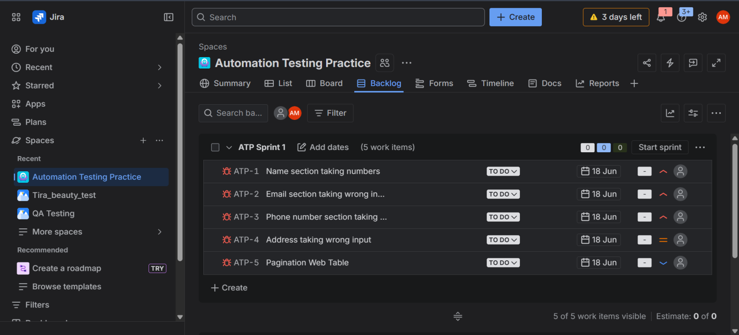

Test Cases analysis Report on Automation Testing Page:
Browser opened
Excel Path: C:\Users\HP\git\Capstone-Project\Automation_testNG\src\test\resources\TestData.xlsx
STARTED : Select_field
All fields entered successfully
PASSED : Select_field
STARTED : Select_field
All fields entered successfully
PASSED : Select_field
STARTED : Select_field
All fields entered successfully
PASSED : Select_field
STARTED : Date_picker
Dates are filled successfully
PASSED : Date_picker
STARTED : Upload_files
File uploaded successfully
PASSED : Upload_files
STARTED : alerts
All alerts handled successfully
PASSED : alerts
STARTED : Tabs
Tab is working properly
PASSED : Tabs
STARTED : Actions
All actions performed successfully
PASSED : Actions
STARTED : Form
Shadow DOM & Form automation completed
PASSED : Form
STARTED : Pop_up
Switched to New Tab URL: https://www.pavantestingtools.com/
New tab closed
Switch to Popup Window URL: https://www.selenium.dev/
Popup Window handled successfully
PASSED : Pop_up
STARTED : Links
URL validation passed
Errors are handled Successfully
PASSED : Links
All tabs closed
Test Execution Completed

===============================================
Automation Suite
Total tests run: 11, Passes: 11, Failures: 0, Skips: 0
===============================================

Smoke Test Report :
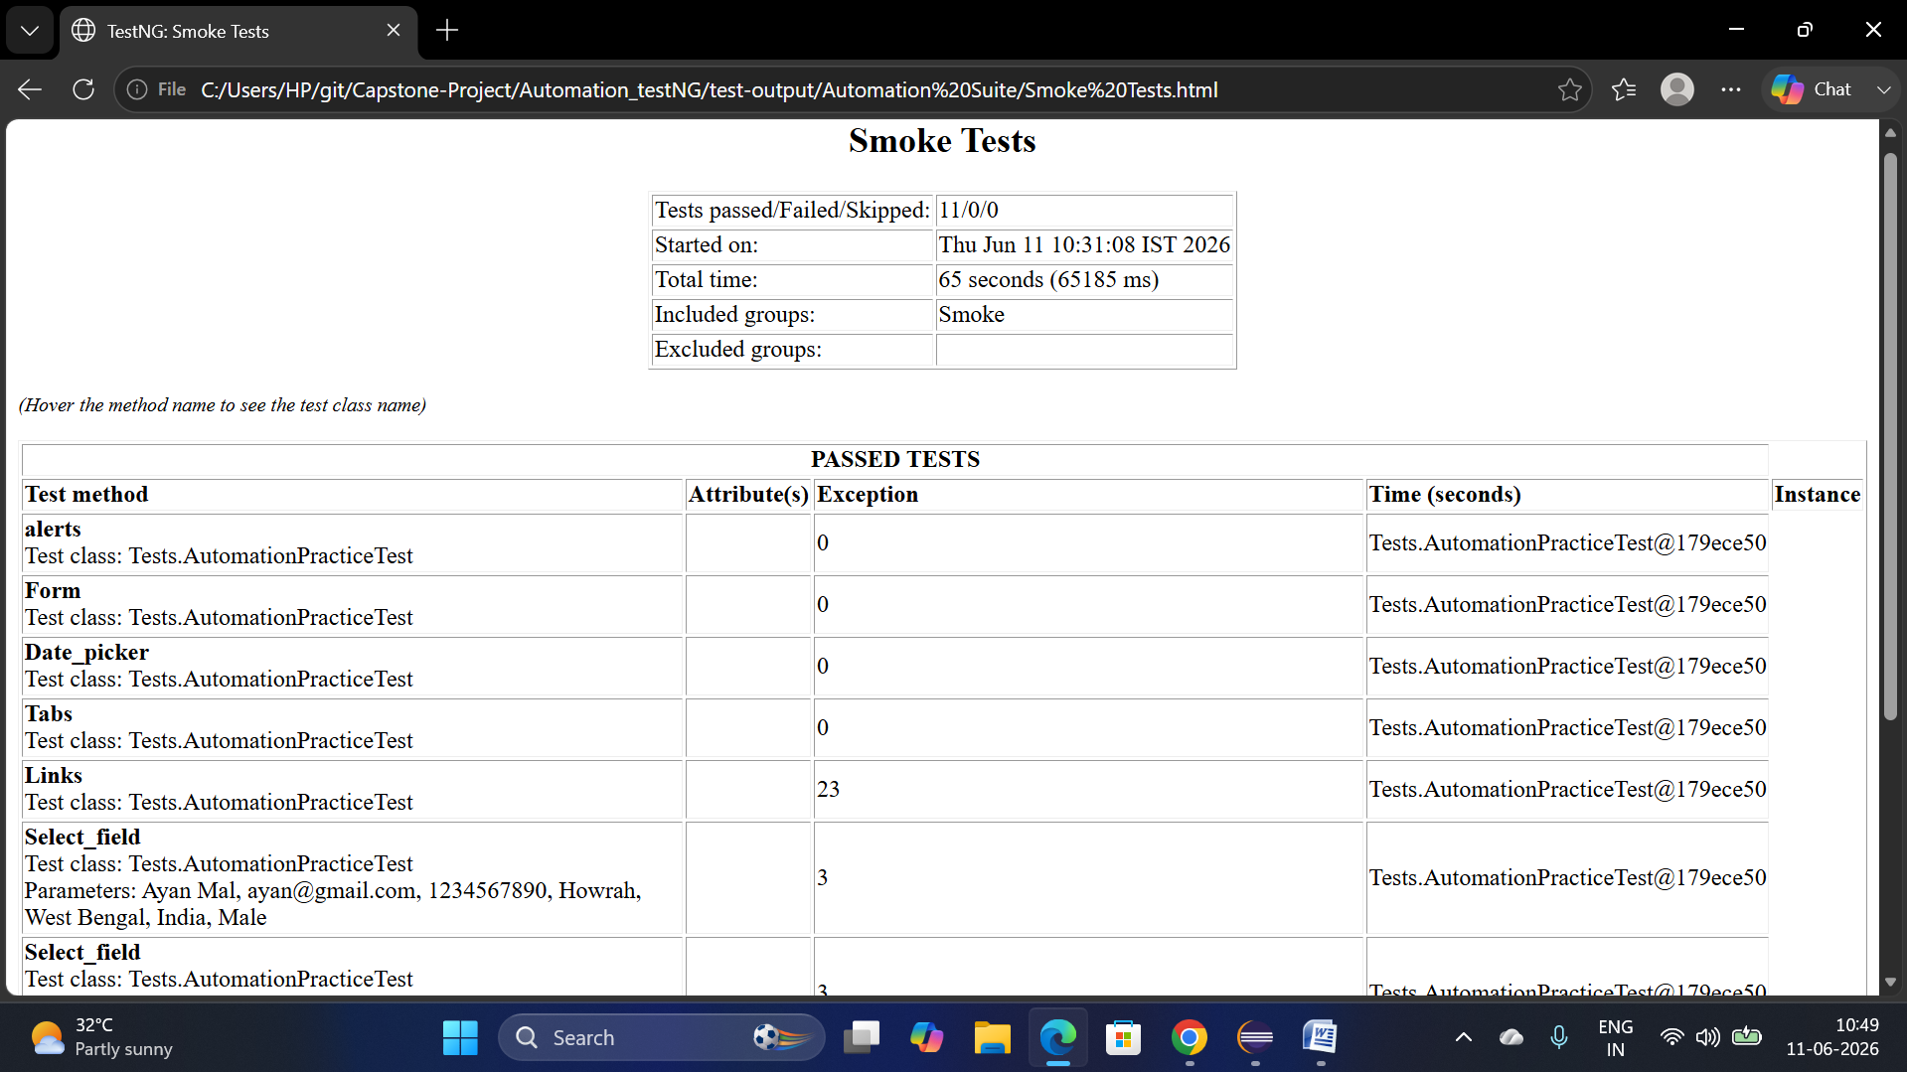

CI/CD Integration using Jenkins and Docker

This the Jenkins integration of the Automation Testing page
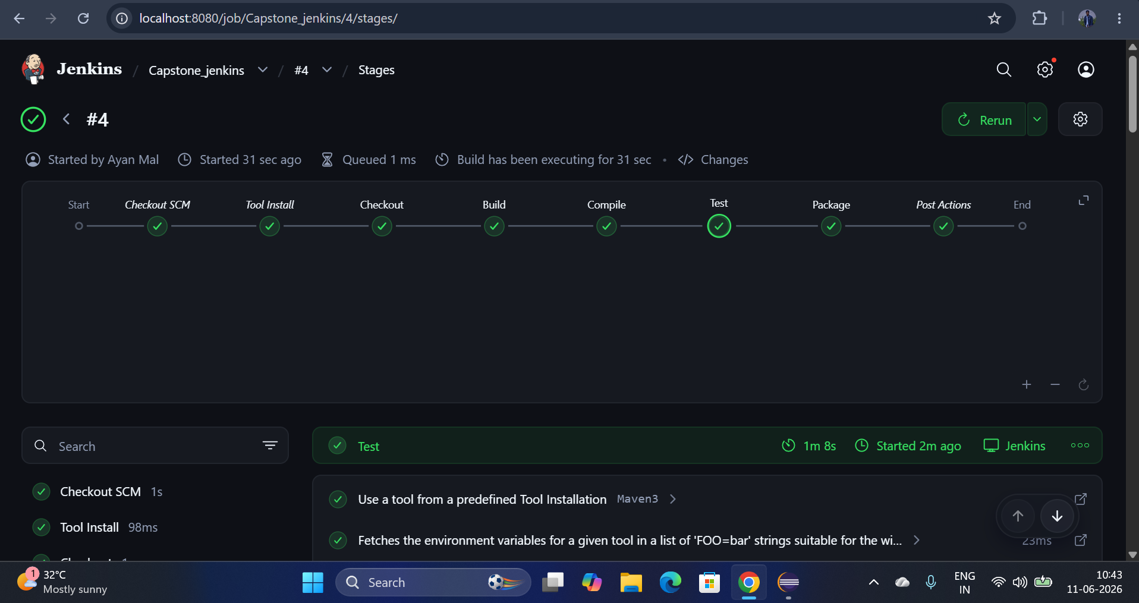
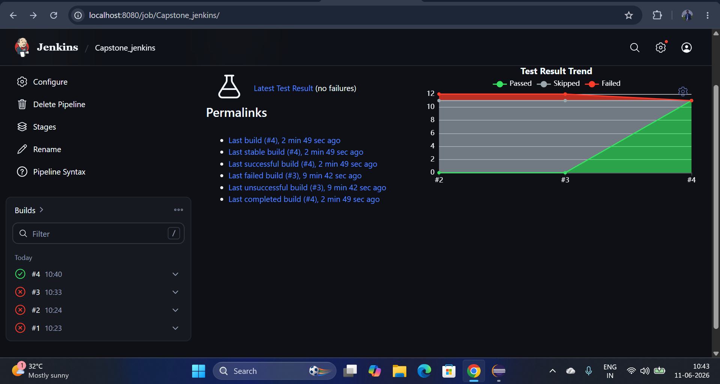

This the Docker integration of the Automation Testing page
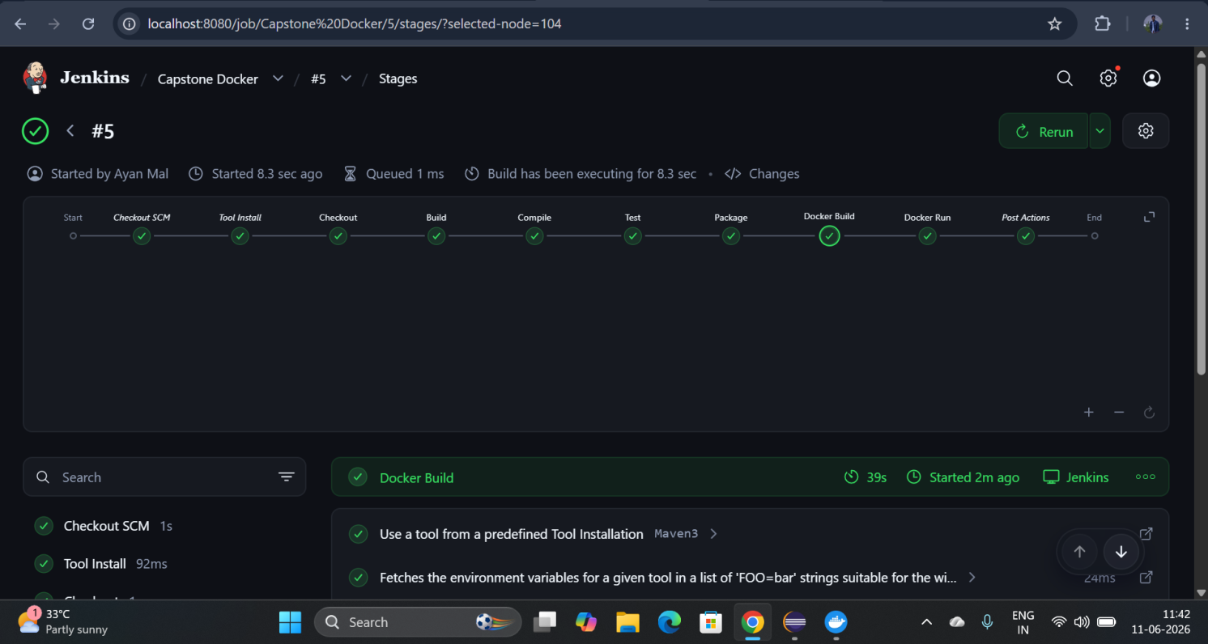
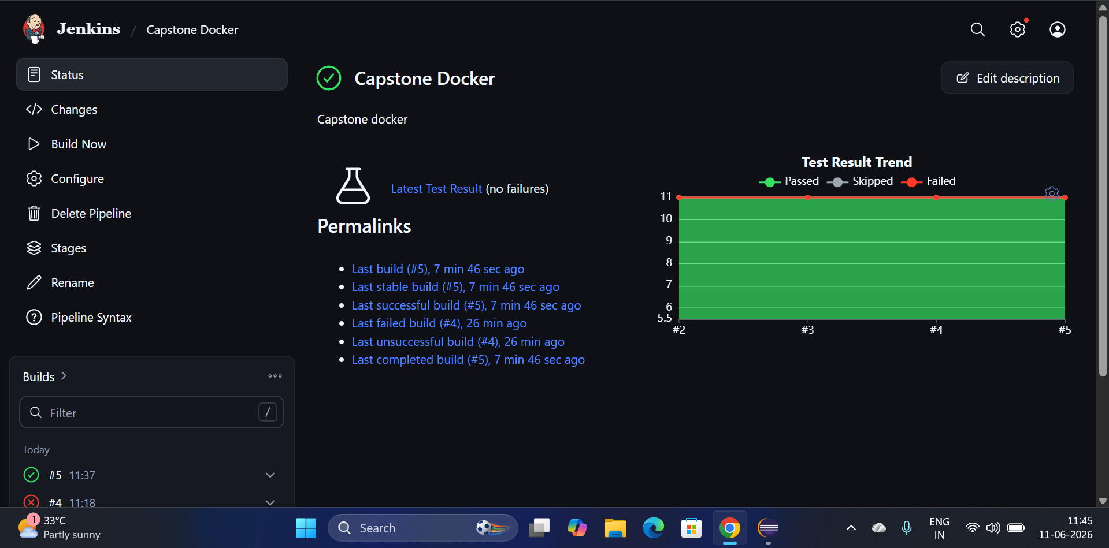

And this is the image which is extracted in Docker Destop:
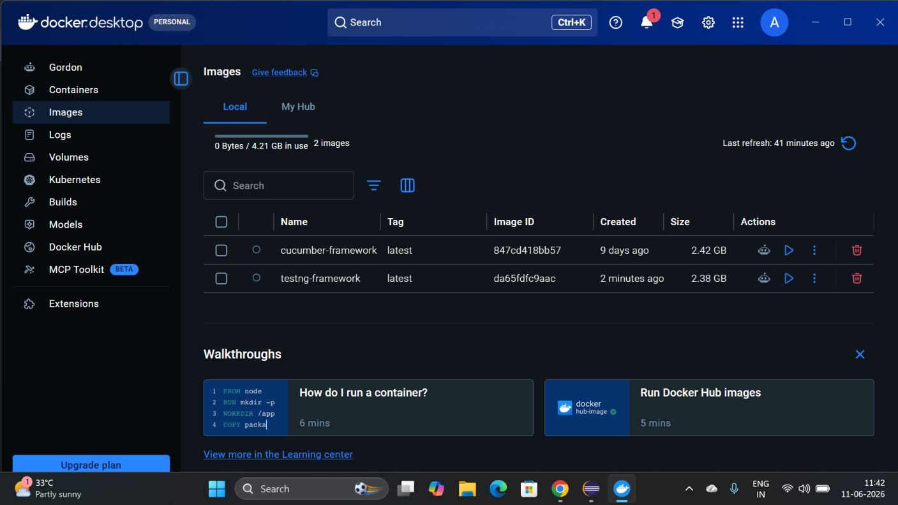

Challenges Faced
• Jenkins Pipeline Setup
• Docker Pipeline Setup
• WebDriver Compatibility with chrome and edge
• excel working
• Managing Test Dependencies

Conclusion
The automation framework successfully validated the major functionalities of the Automation Testing Practice Website, including form handling, alerts, frames, windows, web tables, dropdowns, and mouse actions. The framework supports automated execution through Jenkins, utilizes TestNG for test management, and generates detailed execution reports using Reports, ensuring efficient test monitoring defect tracking and also integrated our project using Jenkins and docker.

